Orofacial pain and temporomandibular joint disorder patient history and questionnaire
Date: ____/____/____
Name: ____________________________ Sex: M F Date of Birth: ____/____/____ Age: ___
Occupation: ______________________ Physician: _______________ Dentist: ______________
Referred by: ___________________ Chief Complaint/Concern: __________________________
______________________________________________________________________________
Location
Please draw where your pain occurs. If you have multiple sites of pain, please number them from one to ten with the most painful site being #1.
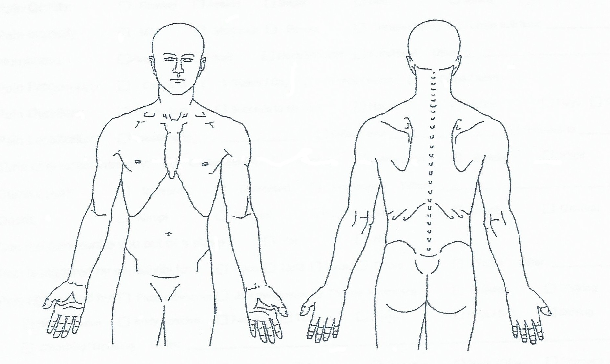
Has the location or type of pain changed since its initial occurrence? No Yes Explain: _________________________________________
____________________________________________________________________________________________________________________
____________________________________________________________________________________________________________________
GENERAL PAIN / PROBLEM ASSESSMENT
Do you have?
Facial Pain No Yes, Rt. Yes, Lt. Past Dental pain No Yes, Rt. Yes, Lt. Past
Jaw Joint Pain No Yes, Rt. Yes, Lt. Past Jaw muscle pain No Yes, Rt. Yes, Lt. Past
Headaches No Yes, Rt. Yes, Lt. Past Neck Pain No Yes, Rt. Yes, Lt. Past
Shoulder Pain No Yes, Rt. Yes, Lt. Past Earaches No Yes, Rt. Yes, Lt. Past
Ringing in the ears No Yes, Rt. Yes, Lt. Past Dizziness No Yes, Rt. Yes, Lt. Past
Change in hearing  No Yes, Rt. Yes, Lt. Past Change in bite No Yes, Rt. Yes, Lt. Past
HEAD and NECK PAIN / SYMPTOMS
- Date of Onset and side: (R) __________ (L) __________
- Area(s) of onset: _____________________________________________________________________________________
- Circumstances surrounding onset, if known: _______________________________________________________________
- Pain Type: Superficial Piercing Throbbing Pulsing Severe Spontaneous Fit-like
- Pain Quality: Burning Aching Bright Dull Itching
- Pain Intensity: Mild Moderate Severe Incapacitating Limits activities: __________________
- Numbness: Face Head Neck/Shoulder Arm/Hand Other: __________________________
- Pain Frequency: Constant ( ) Times/Day ( ) Times/Week ( ) Times/Month
- Pain Duration: Momentary Seconds to Minutes Hours All Day Days Constant
- Pain Localization: Localized to __________________ Diffuse over ___________________ Radiates to _______________
- Time of greatest intensity: On Awakening Morning Afternoon Evening Night
- Current Pain: Increased Decreased Unchanged When? _____________________________
- Onset: Abrupt Gradual Disappearance: Abrupt Gradual
- Can the pain awake you out of sleep? Yes No
- Pain is triggered by sensitivity to: Food Light Sound Odors Touch Other: ___________________
- Pain aggravated by: Face movement Jaw movement Tongue movement Chewing Talking Swallowing
Head position Body position Activity Tension Fatigue Heat/Sun Driving Foods
Clenching/Grinding Other: _________________________________________________________________________________
- Pain accompanied by: Nausea Eye spots Dizziness Sweating Neck stiffness Stomach cramps
- Pain is relieved by: ______________________________________________________________________________________________
- Longest pain-free period? _________________________________________________________________________________________
- Pain in specific teeth? _____________________________________________________________________________________________
- Sore throat or difficulty swallowing? Yes No

EAR / TMJ / DENTAL SYMPTOMS
- Do you have pain in or about the ear(s)? No Yes, right Yes, left
- Do you have dizziness? Spinning Lightheaded Fainting Meniere’s disease
- Do you have ear noise? Ringing: R L Popping: R L Whooshing: R L Clicking: R L
- Have you noticed a decrease in hearing acuity? No Yes Stuffiness Excessive ear wax R L
- Do you have a history of ear infections or operations? No Yes, right Yes, left
- Do you have pains in your Tongue Throat Right cheek Left cheek
- Does your jaw hurt? No Right Left
- Do you have jaw or facial muscle fatigue? No Yes, when: ____________________________________________________
- Have you noticed any facial swelling? No Yes, Right Yes, Left
- Does your jaw make a noise?
Right side No Clicking Popping Grinding Other _________________________
When? __________________________________________________ How long? ________________________________________
Left side No Clicking Popping Grinding Other _________________________
When? __________________________________________________ How long? ________________________________________
- Has your jaw ever locked?
Right side No Yes Current In the past
Open When? ____________________________________ How frequent? ______________________________________
Closed When? ____________________________________ How frequent? ______________________________________
Left side No Yes Current In the past
Open When? ____________________________________ How frequent? ______________________________________
Closed When? ____________________________________ How frequent? ______________________________________
- Do you grind or clench your teeth? No Yes Daytime Night
- Do you have sore or sensitive teeth? No Yes Hot Cold Sweets Chewing
- Do you lose or break filings? No Yes Do you have cracked or broken teeth? No Yes
- Do you have loose or mobile teeth? No Yes Do your gums bleed? No Yes
- Do your gums feel tender or swollen? No Yes Have you ever had periodontal treatment? No Yes
When? __________________________________ Dr. ______________________________________________
- Do you have noticeable wear on your teeth? No Yes Food traps? No Yes
- Are you missing any teeth? No Yes Have they been replaced? No Yes
if so, how? Fixed bridge Removable partial Full denture Dental implant
- Are you comfortable with the replacement? Yes No Comment? ____________________________________________________
- Have you noticed a change in your bite? No Yes When? _______________________________________________________
GENERAL WELLNESS ASSESSMENT
Marital status: Single Married Separated Widowed Remarried
Do you have difficulty getting to sleep? No Yes Do you sleep well? Yes No Sometimes
Is your sleep interrupted? No Yes Do you consider yourself to be under a lot of stress? No Yes
Distress or Mental anguish caused by: Spouse Children Mother Father Friends Work
Economics Other: ____________________________________________________________________________________________
How would you rate your irritability level? Mild Moderate Severe _______________________________________________
How would you rate your anxiety level? Low Moderate High How is it experienced? ___________________________
Ave you had a problem with? None Concentrating Memory Panic attacks Crying spells
Weight loss/gain Libido Anger outbursts Impulsiveness Appetite
Have you had a problem with? None Nervous Stomach Ulcers Skin disease Allergies
Occupation: _____________________________ Hours worked/week: ________ Years employed at present job: _________________
Do you like your job? Yes No Explain: ___________________________________________________________________
Is there anything about your job that causes you excessive stress or anxiety? __________________________________________________________
What job would you like to do? _________________________________ Have you had a change in employment? No Yes
Do you exercise? Daily ( ) x’s per week Rarely Never
What do you do for exercise? ________________________________________________________________________________________________
Do you have or have you ever had arthritis? No Yes Past Where? __________________________________________
Does your family have a history of arthritis? No Yes Past Where? __________________________________________
Does your pain keep you from doing anything? No Yes What? ____________________________________________________
Do you recall any injury to your jaw, head or neck? No Yes Date(s): ___________________________________________________
Describe: ____________________________________________________________________________________________________________________
_____________________________________________________________________________________________________________________________
Do you take any medications for pain? No Yes If yes, what? _______________________________________________
Do you take any medications for relaxation or sleep? No Yes If yes, what? _______________________________________________
Have you had any treatments for your problem? No Yes If yes, what? _______________________________________________
Bite splint _________________________________ Occlusal adjustment _________________________
Medication ________________________________ Orthodontics _______________________________
Physical Therapy ___________________________ Surgery____________________________________
Chiropractic _______________________________ Medication _________________________________
Counseling ________________________________ Other _____________________________________
Please add anything else that you feel is important: ___________________________________________________________________________________
_____________________________________________________________________________________________________________________________
_____________________________________________________________________________________________________________________________
_____________________________________________________________________________________________________________________________
_____________________________________________________________________________________________________________________________
_____________________________________________________________________________________________________________________________
_____________________________________________________________________________________________________________________________

Signature: ____________________________________________________ Date: _______________________________

